# CS 255 System Design Document Template

## UML Diagrams

### UML Use Case Diagram

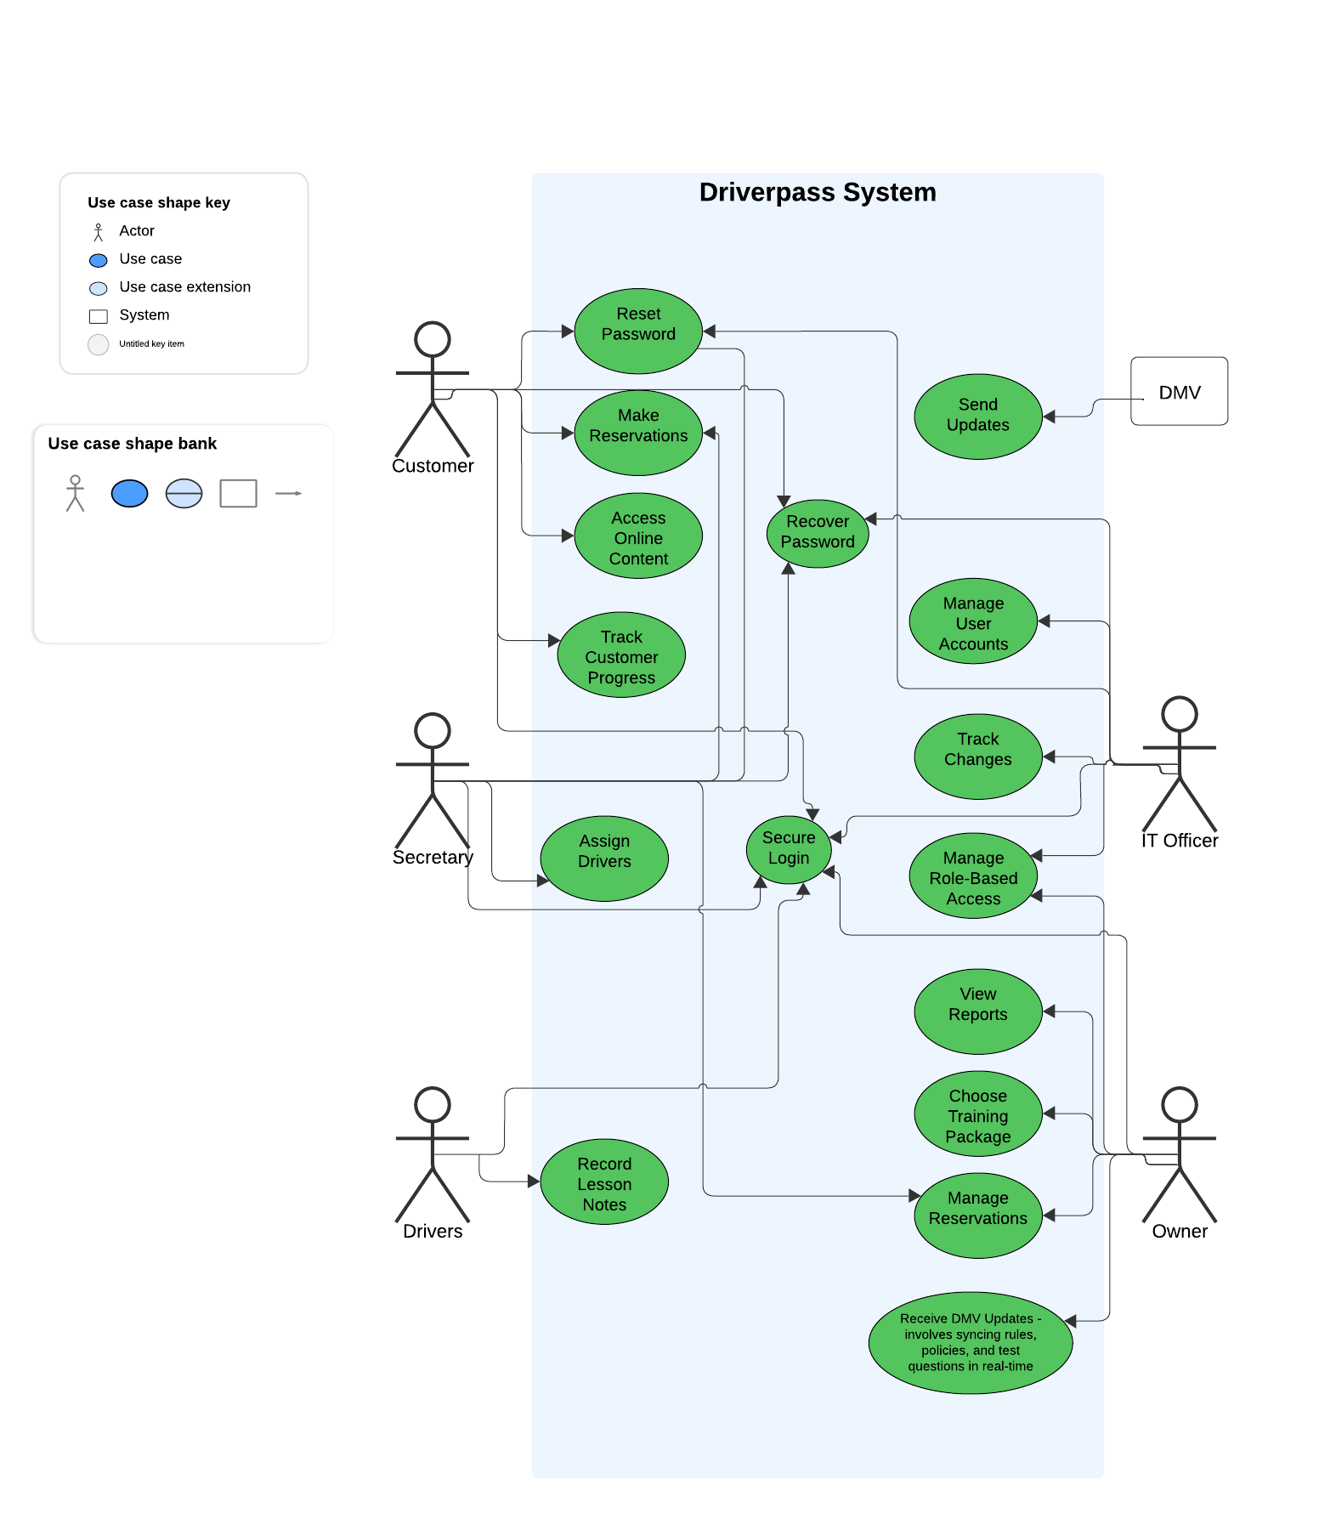

### UML Activity Diagrams

I chose the Reset Password and Make Reservations use case.

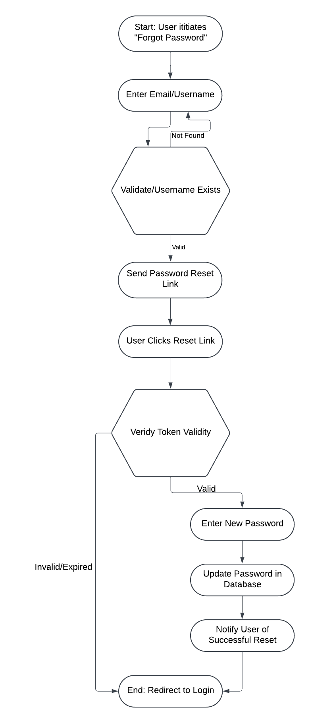

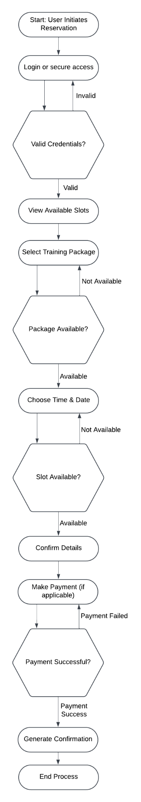

### UML Sequence Diagram

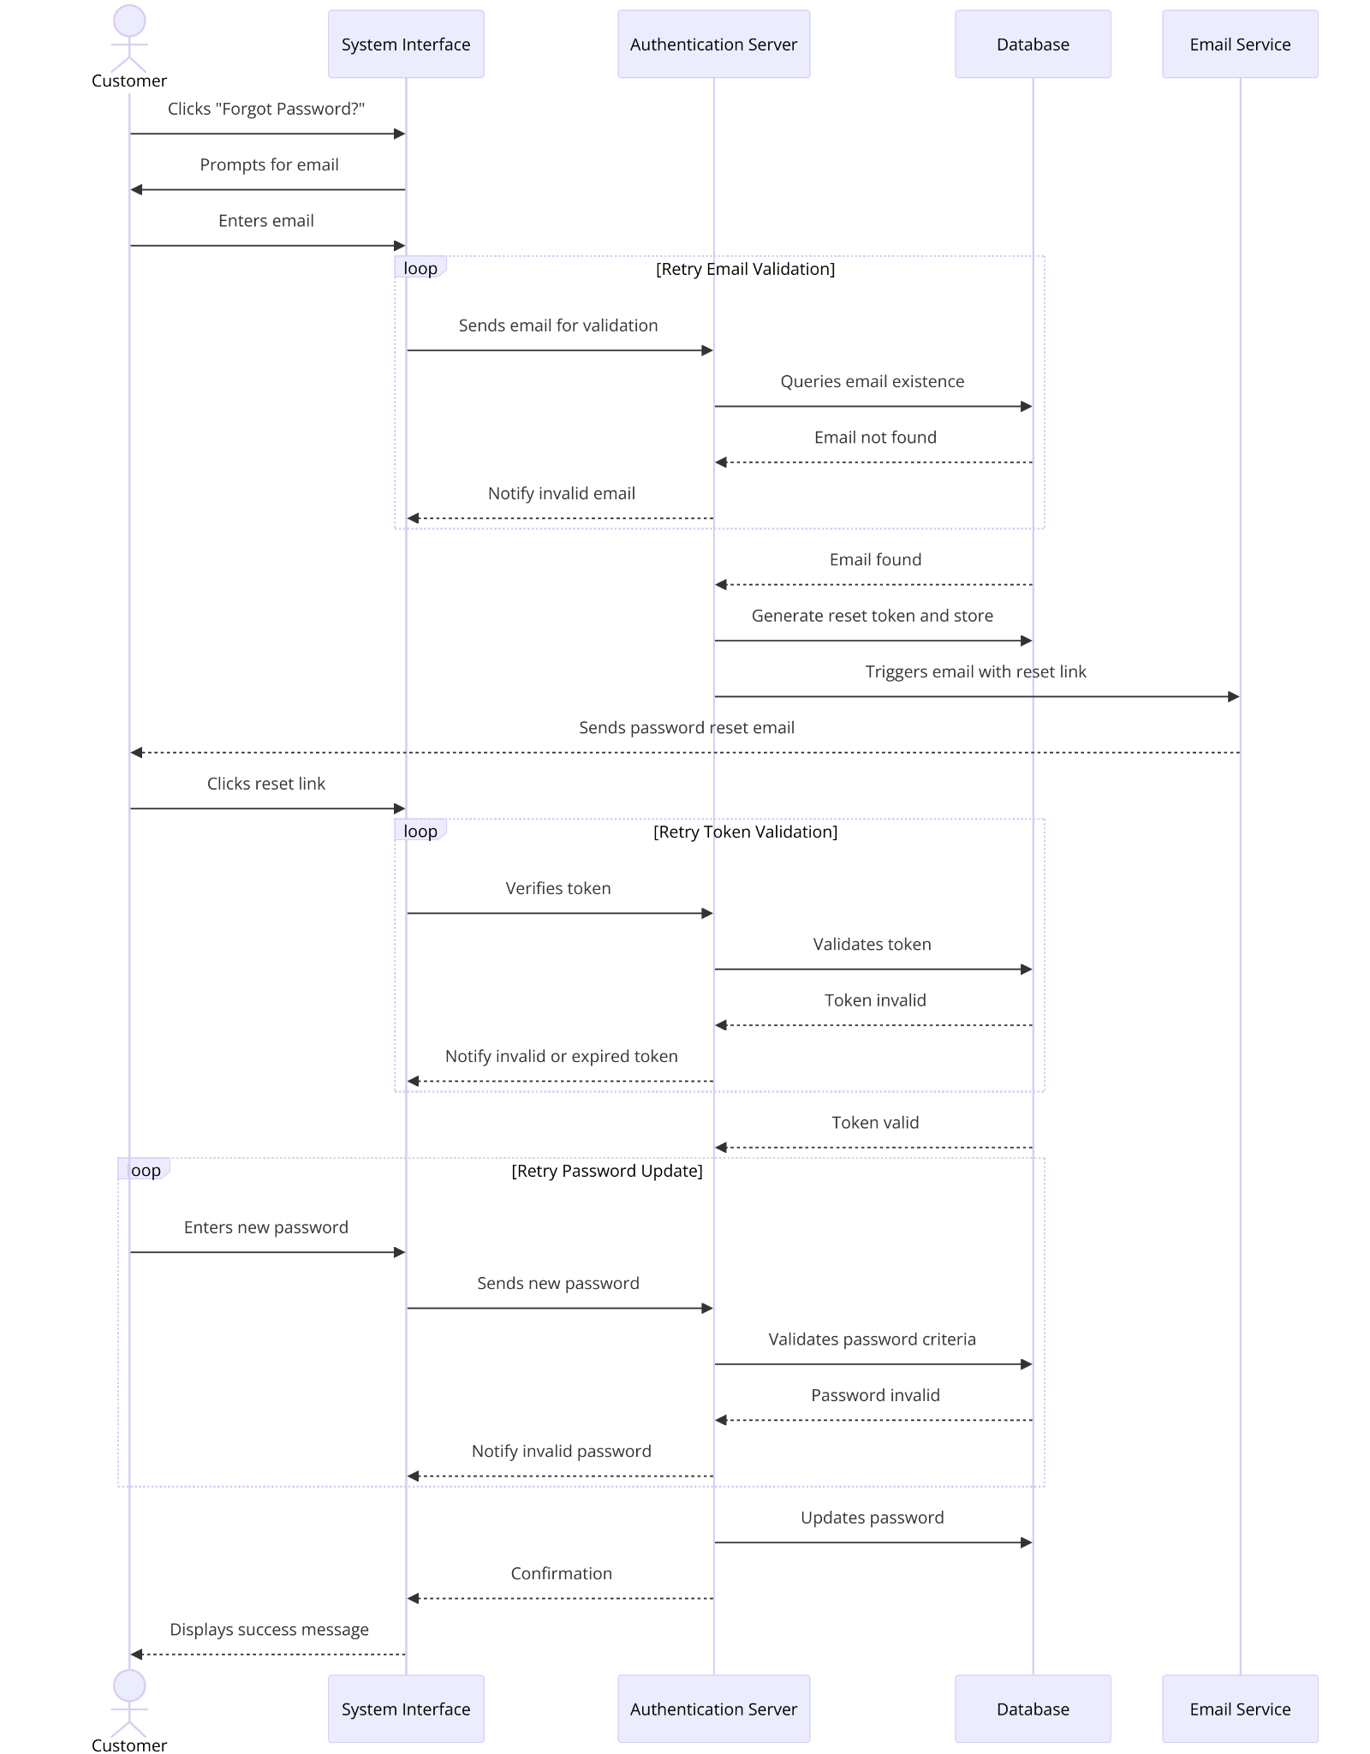

### UML Class Diagram

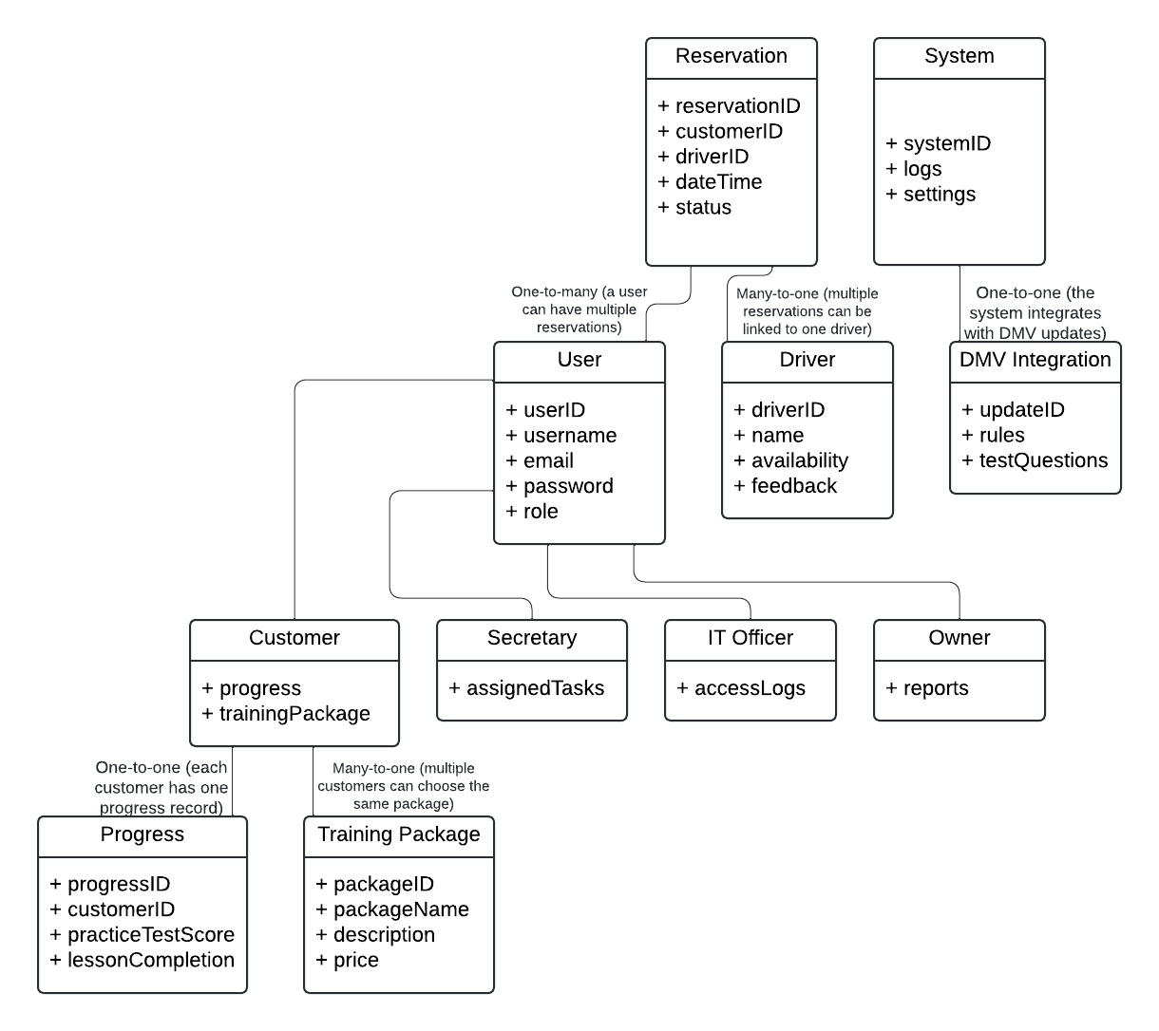

## Technical Requirements

Hardware

* Servers: Use cloud-based servers (like AWS or Google Cloud) to run the system and store data.
* Devices: The system works on computers, tablets, and smartphones with internet access.

Software

1. Backend (Behind the scenes):

* A database (like MySQL) to save user info, appointments, and test progress.
* Software tools (like Python or Node.js) to handle the system’s features.

1. Frontend (What users see):

* Use modern web tools (HTML, CSS, JavaScript) to make it easy to use on both computers and phones.

1. Extras:

* Connect to DMV systems to keep test materials updated.
* Use secure connections (HTTPS) to protect user data.

Infrastructure

* Cloud Hosting: The system will be hosted online, so it’s always accessible and can handle more users if needed.
* Internet Connection: Users need reliable internet to access the system.

Tools

* Development: Tools like Visual Studio Code for coding and Git for saving changes.
* Testing: Use software like Selenium to make sure the system works as expected.

Key Features

* Fast: Pages load in under 2 seconds.
* Secure: Protect passwords and block hackers trying to guess them.
* Expandable: The system is built to add new features in the future.

***References/Citations***

ChatGPT. (n.d.). Presentation & Diagram Generator by . <https://chatgpt.com/g/g-5QhhdsfDj-presentation-diagram-generator-by-showme>

(I used this for the UML Sequence Diagram because Lucidchart stopped me from adding everything I needed to include. Every other chart is mine. I hope this was okay.)